Digitization Process

1. Describe the complete digitization process of an analog entity.
   1. **The Complete Digitization Process of an Analog Entity**

Digitizing an analog entity means converting something that exists in the real world (like sound, light, or physical movement) into a digital form that can be stored, processed, or transmitted by computers. Here is a step-by-step explanation of how this works:

1. **Analog Signal**: An analog entity is something that has continuous signals or data. For example, sound waves, light intensity, or temperature readings are analog because they change smoothly over time without any breaks. These signals can take on an infinite number of values. A common example is the sound produced by a musical instrument, which continuously changes in frequency and amplitude.

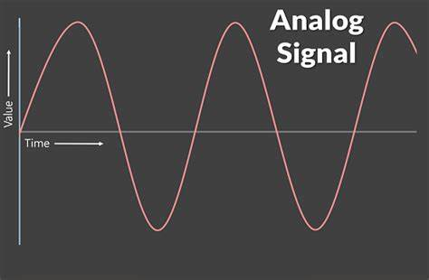

1. **Sampling**: The first step in the digitization process is sampling. This means taking snapshots of the analog signal at specific, regular intervals. If we’re talking about sound, the signal is recorded at regular time intervals (like every 1/44100th of a second for CD-quality sound). The more frequently we take these snapshots (called sampling rate), the more accurate our digital version will be. The higher the sampling rate, the closer it will resemble the original analog signal.

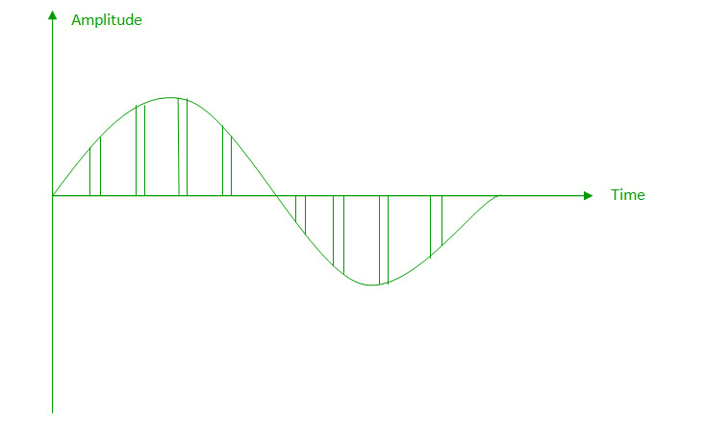

1. **Quantization**: After taking the samples, the next step is quantization. This means converting each sample into a specific numerical value that a computer can understand. Since computers work with numbers, we must represent the continuous values of the analog signal (which can vary infinitely) as discrete numbers. For example, instead of the sound level being "anywhere" between 0 and 100, it will be rounded to the nearest available number, depending on how much detail we need. This step is like rounding the signal to the nearest available number.

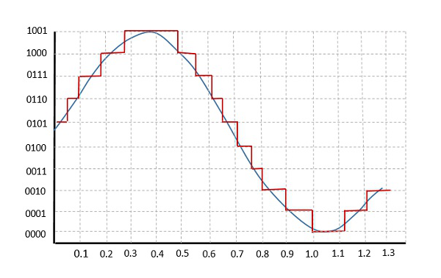

1. **Encoding**: Once the signal has been quantized, the numbers representing the signal are converted into a binary code, which is a language that computers understand (using 0s and 1s). This binary code is what we call the digital version of the analog signal. The more bits used to encode the signal, the better the quality, but the more storage space is needed.
2. **Storage or Transmission**: After the analog signal is digitized, it can now be stored on a computer, CD, or any other digital medium. It can also be transmitted over the internet or through other digital communication systems. The digitized signal is now in a form that can be easily manipulated, stored, and shared.
3. **Reconstruction (Optional)**: Sometimes, we may want to turn the digital signal back into its original analog form. This is called reconstruction, and it involves reversing the digitization process. The digital data is converted back into an analog signal that can be heard through speakers or seen on a screen. However, since we lost some information during the quantization step (because we had to round off the values), the reconstructed signal is never exactly the same as the original.

**Conclusion**: The complete digitization process involves sampling an analog signal, quantizing it into discrete numbers, encoding it into binary form, and then storing or transmitting the digital version. While some details may be lost during digitization, the result is a digital representation that can be easily stored, processed, and transmitted by computers.

1. Describe the following terms: a. Sampling rate, b. Nyquist rate, c. over samplling, d. under samplling, e. threshold of hearing.

A) The **sampling rate** refers to how often an analog signal (like sound or a radio wave) is measured and converted into a digital form. It’s like taking snapshots of the signal at regular intervals. The more frequently we sample, the more accurate the digital version will be. For example, in audio, if we take 44,100 samples per second, we get what’s called a 44.1 kHz sampling rate, which is common for CDs.

B) The **Nyquist rate** is the minimum sampling rate needed to accurately capture an analog signal without losing information. It is twice the highest frequency of the signal. For example, if the highest frequency in a sound is 10 kHz, the Nyquist rate would be 20 kHz. Sampling at or above the Nyquist rate ensures we don’t lose any details in the original signal when converting it to digital.

**Nyquist Rate**: fN ​= 2 × fmax​

* fN is the Nyquist rate (sampling rate).
* fmax ​ is the maximum frequency in the signal.

C) **Oversampling** means sampling the signal at a rate much higher than the Nyquist rate. This extra sampling helps make the conversion process more accurate and smooth out errors or noise. For example, if the Nyquist rate is 20 kHz, oversampling might involve sampling at 40 kHz or even higher, which can help improve quality in some situations.

fs ​> fN​

D) **Undersampling happens when we sample the signal at a rate lower than the** Nyquist rate. This can cause aliasing, where different signals become indistinguishable or "mixed up" in the digital version. For example, if you try to record a high-frequency sound but sample too slowly, the digital version might sound like something else entirely.

fs ​< fN​

E) The **threshold of hearing** doesn't have a formula per se, as it's a physiological limit. However, it’s generally understood as the quietest sound that a human ear can hear, which is around **0 dB** at a frequency of 1,000 Hz for a typical healthy ear. The threshold of hearing is usually represented as:

Lmin = 0 dB SPL

* Lmin is the minimum sound level detectable by the ear (0 dB SPL).
* SPL stands for sound pressure level.

1. Time Domain Feature Extraction Pipeline

A) Time domain feature extraction is a process used in signal processing, where we analyze a signal based on its changes over time. This is important in many fields such as speech recognition, biomedical signal analysis, and vibration monitoring.

Here’s a simple way to understand the time-domain feature extraction pipeline:

**Signal Acquisition:** The first step is to get the signal, usually from a sensor or recording device. This could be anything from an ECG signal (for heart monitoring) to a sound wave or vibration pattern.

**Preprocessing:** Before extracting useful features, we might need to clean the signal. This can include removing noise (unwanted interference) or normalizing the signal so that it’s in a usable range for analysis. This step ensures that the signal is ready for the next stages.

**Segmentation:** The signal is often too long to analyze as a whole, so it is divided into smaller parts or segments. Each segment is then analyzed separately to get more detailed features. These smaller parts are usually based on time intervals.

**Feature Extraction:** Now, we start pulling out important features from each segment. These features help describe the signal's behavior. Common time-domain features include:

* **Mean:** The average value of the signal.
* **Standard Deviation:** How much the signal varies from the average.
* **RMS (Root Mean Square):** The square root of the average of the squared values, used to measure the energy of the signal.
* **Maximum/Minimum:** The highest and lowest values in the signal.
* **Skewness:** Measures the asymmetry of the signal’s distribution.
* **Kurtosis:** Describes the “tailedness” or sharpness of the signal’s peak.

**Feature Selection/Reduction:** Sometimes, not all features are important. We might need to pick out the most relevant features or reduce the number of features to avoid too much complexity. This step is important for improving accuracy and efficiency.

**Classification or Further Analysis:** After extracting the features, they can be used for various purposes like classification (e.g., identifying if a signal indicates a problem in machinery or detecting a specific disease) or other types of analysis, depending on the goal.

**Conclusion:**

In short, the time domain feature extraction pipeline helps us to convert raw signals into meaningful data that can be easily understood and used for various purposes. It involves collecting the signal, cleaning it, breaking it down into smaller parts, extracting key features, and using those features for further analysis. This process is crucial for identifying patterns or making decisions based on time-based data.

1. Frequency Domain Feature Extraction Pipeline
   1. The frequency domain feature extraction pipeline is a method used in signal processing to analyze and extract important information from a signal. The idea is to take a signal (like sound, speech, or any other type of data) and transform it from its usual form (time domain) into a different form where we focus on the frequency components. This helps in understanding the characteristics of the signal that may not be obvious in the time domain. Here's a simple explanation of how the pipeline works:

**Raw Signal Collection**: The first step is to collect the raw signal. This could be any data that changes over time, like a sound recording, sensor data, or an image.

**Transforming the Signal (Fourier Transform)**: To move from the time domain (where we see how the signal changes over time) to the frequency domain (where we see the different frequencies present in the signal), we use a mathematical tool called the **Fourier Transform**. This step turns the raw signal into a representation of frequencies.

**Signal Representation in Frequency Domain**: After applying the Fourier Transform, we get the frequency components of the signal. Each frequency corresponds to a specific pattern or behavior in the signal, like how high-pitched or low-pitched a sound is, or what patterns are present in sensor data.

**Feature Extraction**: Now, we focus on extracting meaningful features from this frequency-based representation. These features could be things like:

* **Dominant Frequency**: The frequency that has the highest amplitude in the signal.
* **Spectral Density**: How much power or energy the signal has at different frequencies.
* **Spectral Entropy**: A measure of the signal's complexity.
* **Band Power**: The total power in specific frequency bands.

**Preprocessing (Optional)**: In many cases, the frequency-domain signal might need some cleaning up. This could include removing noise or filtering out unnecessary frequencies that don’t contribute to the analysis.

**Final Feature Set**: After extracting the features, we have a set of values that describe the signal in the frequency domain. These features can now be used for further analysis, like classification, prediction, or pattern recognition.

**Post-Processing**: Depending on the task at hand, additional steps might be needed, such as normalization or scaling of the extracted features to ensure they are in a usable form for machine learning models or other applications.

**Example in Real Life:**

Let’s say we’re working with a sound signal, like a recording of someone's voice. If we take the Fourier Transform, we can see which frequencies are more dominant in the person's voice—whether they’re speaking in a high-pitched or low-pitched tone. By extracting features like the dominant frequency and the spectral density, we can later use this information to classify the voice, recognize speech patterns, or even detect emotions.

**Conclusion:**

In simple terms, the frequency domain feature extraction pipeline helps us to transform a signal into a form that reveals important characteristics hidden in the frequency components. By focusing on frequencies rather than time, we can gain insights and make decisions based on those features, which is especially useful in fields like sound analysis, speech recognition, and sensor data processing.